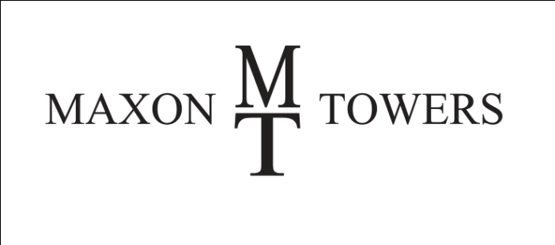

CONSUMER NOTICE

THIS IS NOT A CONTRACT

Prudential Realty Co. hereby acknowledges that with respect to Maxon Towers 6315 Forbes Avenue, Pittsburgh, PA 15217, Chi Quach is acting as an agent of the owner/landlord pursuant to a property management agreement.

I acknowledge that I have received this notice:

Tenant Name: ___________________________________________________

(Please print)

Tenant Signature: ________________________________________________

____________________________

Date

I certify that as an agent of the owner/landlord I have provided this notice to the tenant:

____________________________ ___________________________

Chi Quach, Property Manager Date